Arduino Control Flicker System Set Up
By Shirin Kale
based on set-up from Hannah Iaccarino and Annabelle Singer

Components
- two 16v, 47µF polarized capacitors
- two 25 Ohm, 5W resistors
- one MOSFET N-CH 60v, 2.5A, 4-DIP (note: a MOSFET is a metal-oxide semiconductor field-effect transistor)
- three breadboard jumper wires (two longer and one shorter)
- LED strip with 4-pin connectors (from LEDs Super Bright: Flexible LED Strip Lights, white; DC powered by 9-12V)
- a 12v power supply
- a breadboard
- Arduino UNO (R3 Microcontroller SMD Model: A000073)

Tools
- electrical tape
- scissors
- wire cutter/stripper

Instructions
Connecting the power supply
- Using a wire cutter, cut off the end of the output cable.
- You should now be able to see the two wires that make up the cable: one red, another white. Strip the outer cable so that you can separate the red and white wires within it.
- Now strip the end of the red wire. Then strip the end of the white wire.
- Take the red wire and connect it to the red bus (12v power) on the right side of the breadboard.
- Take the white wire and connect it to the blue bus (12v ground) on the left side of the breadboard.

Connecting the capacitors
- Take one of the capacitors and identify the positive leg. Usually, the positive leg is the longer leg.
- In row 5, connect the positive leg of the capacitor to power (red bus) and connect the negative leg of the capacitor to ground (blue bus). If your capacitor legs are not long enough, you can attach a jumper wire to one of the legs, making it an extension of the leg.
- Using another capacitor, connect the negative leg to 20H and connect the positive leg to 22H.

Connecting the resistors
- Take one of the resistors and connect one of the legs to 22I and the other leg to power (red bus) in row 39.
- The other resistor should connect to 22J and power (red bus) in row 41.

Connecting the MOSFET
- Looking at the MOSFET: identify the side where the two pins are not connected to one another. These two pins are the source and the gate. On the other side of the MOSFET is the drain, which is the side where the two pins are connected to each other.
- Connect the source and the gate to 19E and 20E, such that the drain is connected to 19F and 20F.

Connecting the jumper wires and arduino
- Using the shorter jumper wire (it’s black in the schematic), connect one end to ground (blue bus) at row 19 and connect the other end to 20A.
- Using one of the longer jumper wires (it’s yellow in the schematic), connect one end to 19A and connect the other end to 7 on the arduino.
- Using another longer jumper wire (it’s blue in the schematic), connect one end to ground (blue bus) at row 49 and connect the other end to GND on the arduino.

Connecting the LED strip
- Separate the two wires of the LED cable and strip the ends of each of them.
- One of the wires is “white” (has white dashed lines along the entire length of the wire). This wire is the ground. Identify this wire and connect it to 22G.
- Connect the other wire to 20G.
- The other end of the LED cable is a 4-pin connector. Connect this to one of the ends of the LED strip.

Connecting the arduino
- Now that everything is set up with the breadboard, the last step is to connect the arduino to your computer via USB cable.

Downloading the arduino software
- Go to this link and click on the operating system that corresponds to the computer you’re using: https://www.arduino.cc/en/Main/Software
- Once you download it, open the software by double-clicking and copy&paste your code. If you have the code saved on your computer, you can also go to File —> Open and then select the .ino file containing the code.

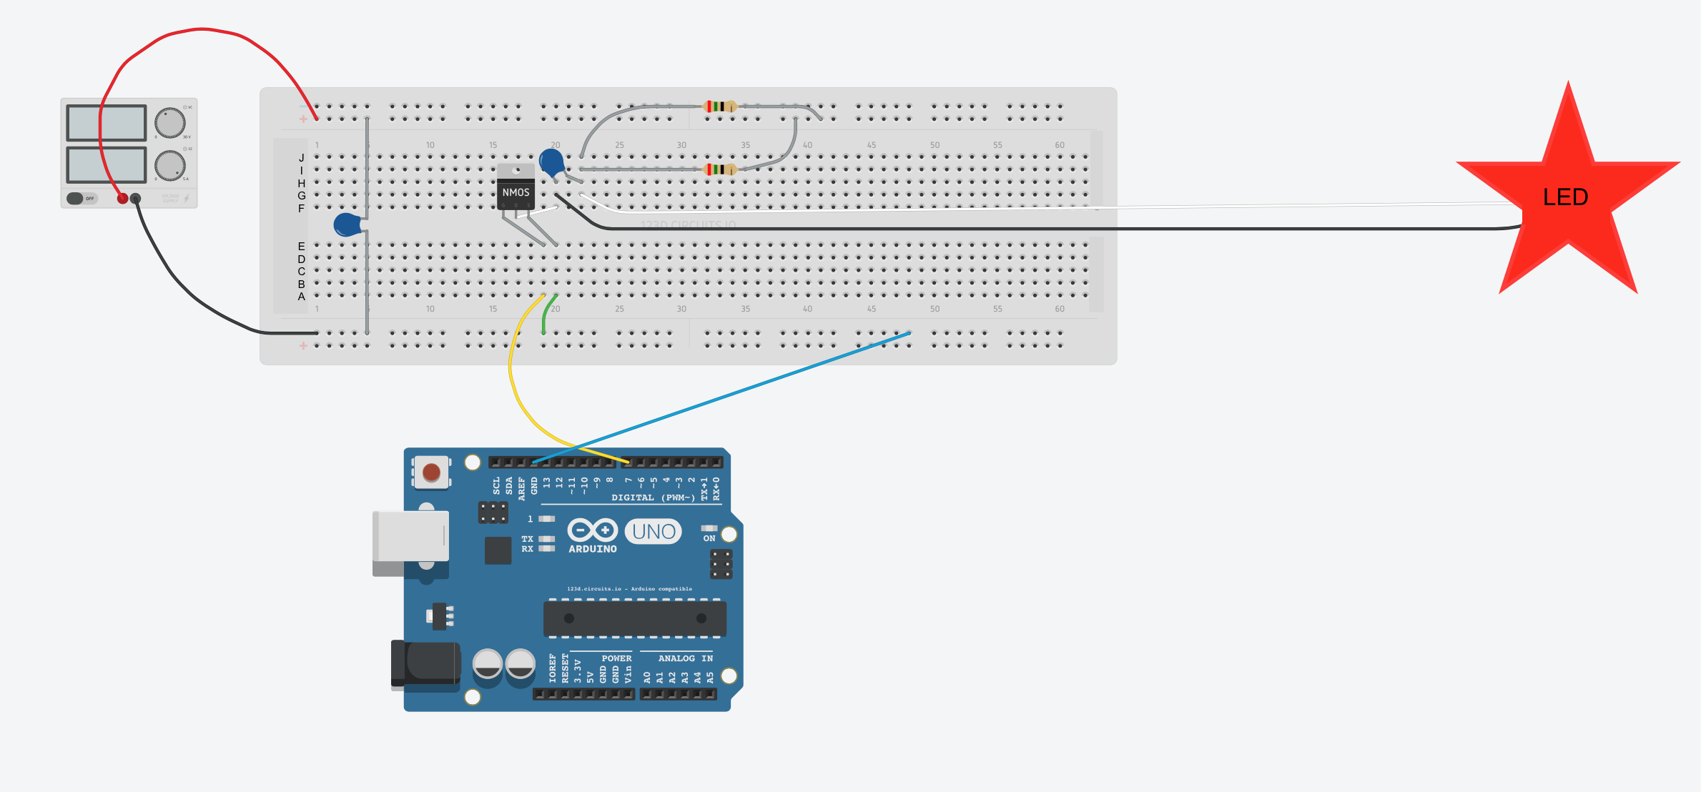
Schematic of Circuit
12V DC
power
supply

Product Numbers for Components

Component | Product Number
CAPACITOR ALUM 47UF 20% 16V RADIAL | DigiKey: 493-5361-1-ND
RESISTOR 25 OHM 5W 1% AXIAL | DigiKey: 696-1075-ND
MOSFET N-CH 60V 2.5A 4-DIP | DigiKey: IRLD024PBF-ND
Z&T ® Solderless Flexible Jumper Wires | Amazon ASIN: B005TZJ0AM
Flexible LEDs | LEDsSuperBright.com: Flexible LED Strip Lights by the Foot, white  or  SuperBrightLEDs.com: NFLS-NW30X3-BK-LC2
Solderless Breadboard | DigiKey: 438-1045-ND
Arduino Uno R3 Microcontroller SMD (Model: A000073) | Amazon ASIN: B008GRTSV6

